说明书

流域重金属行为模拟模型输入输出系统V1.0

周凌峰

中国环境科学研究院

2022年8月

**SWAT-HM**

**User’s manual**

**August 2022**

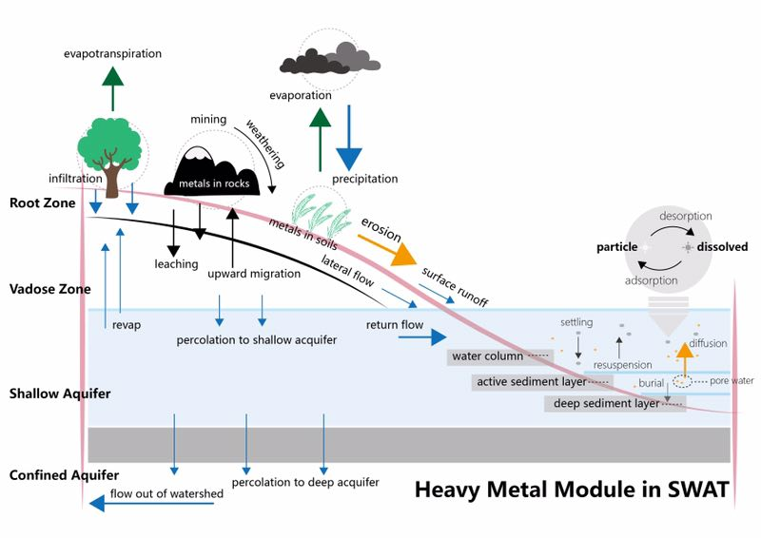

**Lingfeng Zhou**

Chinese Research Academy of Environmental Sciences, China

# SWAT-HM description

SWAT-HM (Soil and Water Assessment Tool – Heavy Metal) was developed to simulate the fate and transport of heavy metals (HM) at the watershed scale. SWAT-HM provides a process-based representation of the metal behavior from uplands to streams and down to the watershed outlet. Fig. 1 illustrates a schematic diagram of the main processes (upland and channel processes) of the SWAT-HM. SWAT-HM operates at a daily time step, tracking the stores and fluxes of dissolved and particulate metals in both the land and in-stream phases of a catchment. Fig 2 displays the command loop of SWAT-HM code.



Fig. - Schematic framework of heavy metal module coupled with the SWAT model

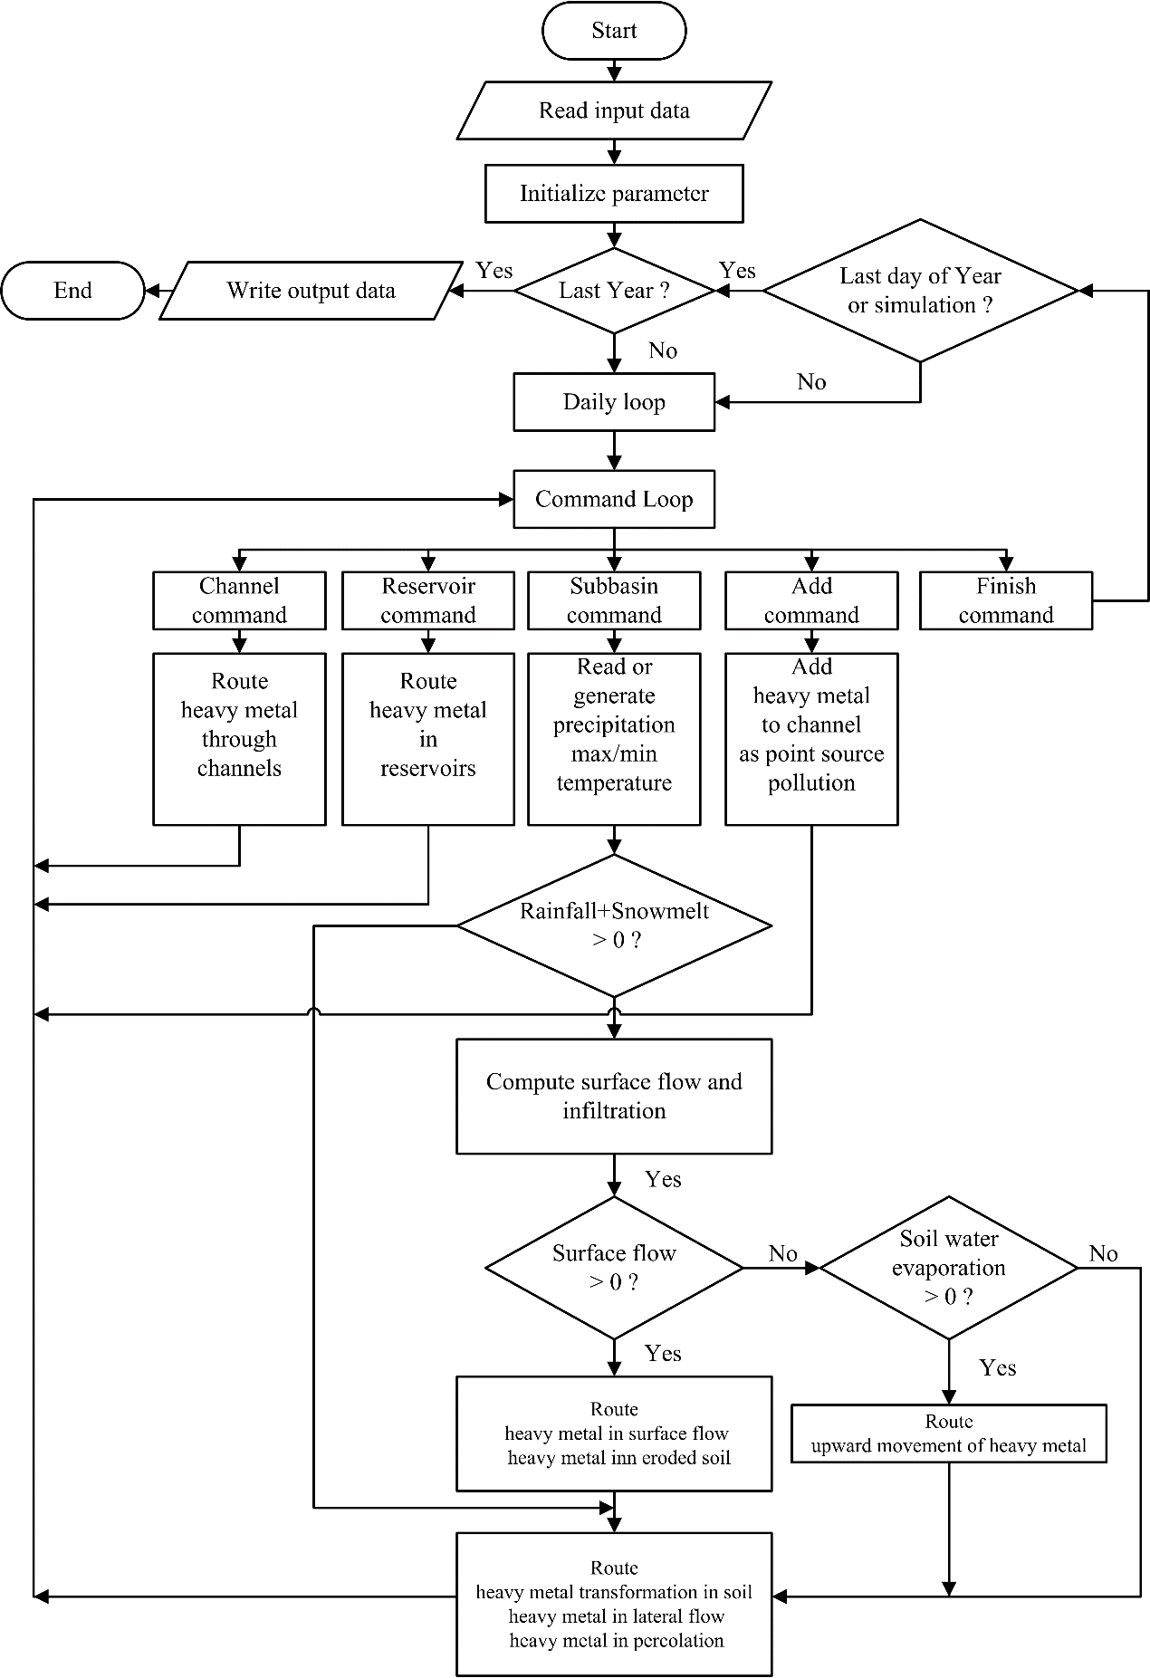

Fig. – SWAT-HM command loop

## Heavy metal transformation module

In this section, we first introduce the transformations module followed by the transport module specifications because of the dependence of metal mobility and bioavailability on its chemical speciation. In the natural environment, there are numerous reactions that affect the speciation of metals, such as sorption (adsorption/desorption), complexation (association/dissociation), precipitation, diffusion into carbonates and oxyhydroxides. In the solid phase, metals are present as labile, non-labile, and inert metal. Labile metal is part of the solid-phase metal that is rapidly exchangeable with the solution phase. Inert solid metal is the case for metals present in parent minerals, which is unlikely to control the ion activity in soil solution. The metal of ‘labile’ pool on the solid phase can be slowly transferred from/to a non-labile pool. The transfer from labile to non-labile pool is a slow process takes years or longer. In the solution phase, metals are present as free ions, as complexes with inorganic or organic ligands, or associated with mineral colloids. The free ion in solution is generally the most reactive species in terms of reaction with the solid phase. Metal ions adsorb to organic matter, oxyhydroxides and clay minerals. Similar to the inert solid metal, some metals in solution may be equally non-reactive, such as metals in colloidal minerals.

Fig. 3s a-d illustrate different levels (level 0-3) of complexity about potential reaction mechanisms, in increasing order of simplicity. The level 3 scheme (Fig. 3a) represents all the main processes mentioned above. It is conceptually attractive, but requires extensive input information, which is often not available in routine research. In the level 2 scheme, the differences between non-labile and inert metals, in both solid and solution phase, are not considered. However, the successful application of level 2 scheme requires the accurate modeling or observation of dissolved organic matter (DOM). As a watershed-scale model, we consider level 1 and level 0 scheme are practically useful. The level 1 SWAT-HM model consists of 3 pools: dissolved metal (*M*d), labile metal (*M*l), and non-labile metal (*M*n), in which free metal ions (*M*n+) and metal complexes (*ML*) in solution are regarded together as dissolved metal (*M*d). The last, most simplified, level 0 SWAT-HM transformation module consists of 2 pools: dissolved metal (*M*d) and particulate metal (*M*p), in which labile metal (*M*l) and non-labile metal (*M*n) are further regarded together as particulate phase metal (*M*p).

In level 1 model, two major types of reactions are taken into account in the heavy metal transformation model: (1) sorption, and (2) slow reaction (details in Table 1). Sorption reaction refers to the adsorption-desorption processes between the dissolved metal in the solution phase and the labile metal in the solid phase. Many studies have demonstrated that adsorption-desorption is the most important process affecting the mobility and bioavailability of metals (Degryse et al., 2009). The “slow reaction” refers to all the slow chemical processes (between labile and non-labile phases) in the solid phase, such as the intra-particle diffusion of metals in carbonates and oxyhydroxides. This is included in SWAT-HM because of its importance for long-term metal prediction (Buekers et al., 2008; Crout et al., 2006). Generally, the sorption reaction is much faster than the solid phase slow reaction, which occurs over months or years. Ernstberger et al. (2002) measured the adsorption and desorption rates of Zn, Cd, Ni, and Cu and found that the sorption response time ranges within several minutes (*T*1 *c* = 300-3,000 s in Table 1). For the solid phase slow reaction, Buekers et al. (2008) used the simple first-order reversible reaction to measure response time and reaction rates (*T*2 *c* = 124-800 d in Table 1). Therefore, for the sorption reactions, we adapted the classical local equilibrium assumption (Bahr and Rubin, 1987; Chapra, 2008; Rubin, 1983), i.e., the equilibrium constant (*K*d) is used in modeling sorption reaction. In contrast, for the slow reactions, the kinetic approach characterized by reaction rates (*k*1, *k*-1) has to be followed to describe the slow reaction, as the slow reaction is too vanishingly slow to attain an equilibrium within the daily time scale (*T*2 *c* >> 1 d).

Dissolved metals (solution phase, [*M*d]) are reversibly adsorbed onto solids and become labile adsorbed metals (solid phase, *M*l). The solid-solution partition coefficient (*K*d) is defined as the ratio of the labile metal concentration in the solid phase to the dissolved metal concentration in the solution phase when equilibrium is attained:



where *K*d is the solid-solution partition coefficient (L kg-1), and *M*l and [*M*d] denote the labile metal concentration in the solid phase (mg kg-1) and dissolved metal concentration in the solution phase (mg L-1), respectively.

Furthermore, the kinetic rates (*k*1, *k*-1) of the slow reaction are specified to allow for the reversible conversion between the labile adsorbed metals(*M*l) and their non-labile counterpart(solid phase, *M*n).



where *k*1 and *k*-1 are forward and backward rates of slow reaction ( d-1), and *M*l and *M*n denote the labile and non-labile metal concentration in the solid phase (mg kg-1).



Fig. - Graphical descriptions of the metal transformation model in the soil-water environment. *K*d, *k*a, *k*d, *k*ads, *k*des, *k*1 and *k*-1 denote the equilibrium and rate constants.

Table - Two major reactions in the soil-water environment and their kinetics equations, equilibrium constants, response times and reaction rates.

|  |  |  |  |  |  |  |  |  |
| --- | --- | --- | --- | --- | --- | --- | --- | --- |
| **Reaction** | **Formulation** | **Kinetics equation/Equilibrium constant /response time** | **Reaction rate** | | | | | **Reference** |
| (1)  Sorption |  |  |  | **Zn** | **Cd** | **Ni** | **Cu** | Ernstberger et al. (2002) |
| (103 s-1) | 3.31 | 1.41 | 1.24 | 33.2 |
| (106 s-1) | 25 | 16 | 1.5 | 9.5 |
| (s) | 300 | 700 | 800 | 3000 |
| (2)  Slow reaction |  |  |  | **Zn** | **Cd** | **Ni** | **Cu** | Buekers et al. (2008) |
| (104 d-1) | 8.37 | 7.25 | 48.4 | 32.6 |
| (104 d-1) | 12.6 | 5.25 | 32.3 | 22.7 |
| (d) | 478 | 800 | 124 | 181 |

.

Table - Selected regression models for log*K*d (in L kg-1), derived from pore-water based *K*d values. The regression equations were fitted with *K*d values that were based on total solid phase concentrations (*K*dtot/free) or on labile solid phase concentration (*K*dlab)

|  |  |  |  |  |
| --- | --- | --- | --- | --- |
| **Metal** | **Kd** | **Regression equation** | **N** | **R2** |
| Cd | *K*dtot |  | 123 | 0.65 |
| Cd | *K*dtot |  | 122 | 0.72 |
| Cd | *K*dlab |  | 86 | 0.66 |
| Cd | *K*dlab |  | 86 | 0.71 |
|  |  |  |  |  |

## The framework of the heavy metal module in the upland

A framework of the heavy metal module on land is depicted in **错误!未找到引用源。**a. Within this frame, the SWAT model undertakes the hydrological and sediment processes that serve as external driving forces of the heavy-metal module. The mass balance equation of metals in the soil profile is expressed as Eq. (3).



Where *M*atmo is the metal input from atmospheric deposition, *M*weth is the metal input from weathering of waste rocks, *M*fer is the metal input from chemical fertilizer and manure; while metal outputs include plant metal uptakes (*M*pu), metal leached down out of soil profile (*M*perc,ly=n, bottom soil layer), and metal exports from upland to the river channel with surface runoff (*M*surf), lateral flow (, all soil layers) and soil erosion (*M*ero).

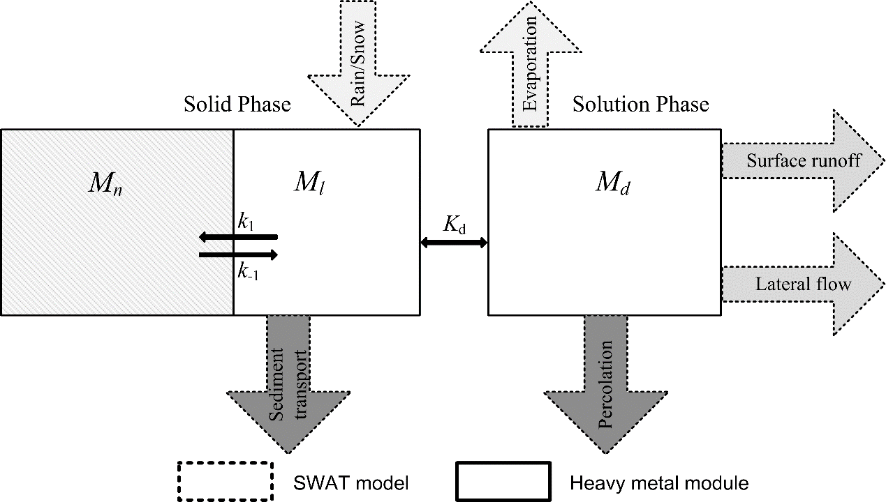

Fig. - Schematic framework of heavy metal transport and transformation in the upland. Metals in the solution phase transport with surface runoff, lateral flow, percolation and upward migration with evaporation; metals in the solid phase transport with soil erosion.

### *Leaching*

Heavy metal in the solution phase of soil layers can be transported with surface runoff *Q*surf, lateral flow *Q*lat and percolation *Q*perc. For each soil layer, the amount of metal moved with water flow *M*flow, is a function of time, initial metal concentration and flow rate *w*mobile (surface runoff, lateral flow and percolation for the topsoil layer, *w*mobile = *Q*surf + *Q*lat + *Q*perc; lateral flow and percolation for the lower soil layers, *w*mobile = *Q*lat + *Q*perc), as shown in Eq. (4).



where *M*flow is the amount of heavy metal transported with flow in the soil per hectare (kg ha-1), for the top soil layer ly = 1, *M*flow,ly = *M*surf,ly + *M*lat,ly + *M*perc,ly; for the lower soil layers ly = 2,...,n, *M*flow,ly = *M*lat,ly + *M*perc,ly. *M*0,ly is the initial amount of mobile heavy metal for each soil layer per hectare (the sum of the *M*d and *M*l amounts, kg ha-1), *t* is the time, *w*mobile is the amount of mobile water (mm), *SAT* is the saturated soil moisture (mm), *d* is the depth of the soil layer (mm), and* * is the soil bulk density (kg m-3).

### *Movement with soil erosion*

When soil erosion occurs, heavy metals in the solid phase migrate with the solids, and the amount of transported metal with eroded soil *M*ero is expressed as shown in Eq. (5).



where *M*ero is the amount of heavy metal transported with eroded soil per hectare (kg ha-1), *M*l and *M*n are the concentration of labile or non-labile metal in soil (mg kg-1), respectively, *sed*ero is the amount of sediment transported to the channel per hectare (kg ha-1), ** is the enrichment ratio of heavy metal (Quinton and Catt, 2007).

### *Plant uptake*

SWAT simulates crop growth by a simplified method of the Erosion-Productivity Impact Calculator (EPIC) model (Williams, 1990). In SWAT, the phenological plant development is based on daily accumulated heat units, potential biomass is based on a method developed by Monteith (Monteith et al., 1977). We used the common approach called plant uptake factor (*PUF*) to model the plant uptake process. Being straightforward, this approach relies on the *PUF* factor which is defined as the ratio of metal concentration in the plant (mg kg-1) to that of soil (mg kg-1). The amount of metal uptake by plant *M*plt is expressed as Eq. (6).



where *M*pu is the amount of heavy metal transported from soil to plant per hectare (kg ha-1), *M*l and *M*n are the concentration of labile or non-labile metal in soil (mg kg-1), respectively, *PUF* is the plant uptake factor (-), and *bio_ms* is the plant biomass per hectare (kg ha-1).

## The framework of heavy metal module in the water body

Adapted to the framework of SWAT, which assumes a well-mixed and 1-D water body (Debele et al., 2008), a simple mass balance method is used to simulate the in-stream processes including settling, resuspension, diffusion, and burial (Fig. 5). The mass balance equations of metals in water column and bed sediment are expressed as Eq. (7) and (8).





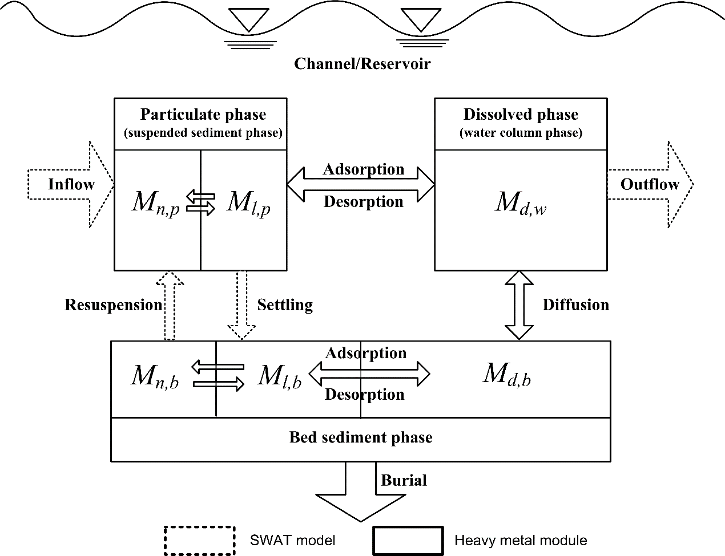

Fig. - Schematic framework of heavy metal transport and transformation in the water body. The processes of adsorption and desorption, settling and resuspension, diffusion, and burial are included.

### *Settling and resuspension*

The sediment budget obtained in SWAT is used to determine the settling or resuspension amount of heavy metal:





where *M*set and *M*res are the amounts of settled and resuspended heavy metal (kg), respectively; *sed*set and *sed*res are the amounts of settled and resuspended sediment (kg), respectively; *M*l,p and *M*n,p are the concentrations of the labile and non-labile metal in the suspended sediment (particulate phase, mg kg-1), respectively; *M*l,b and *M*n,b are the concentrations of the labile and non-labile metal in the bed sediment (mg kg-1), respectively.

### *Diffusion*

The transport of dissolved metal species between the water column and riverbed pore water is a diffusion process controlled by the concentration gradient (Lick, 2008). That is, the dissolved metal in the water column can diffuse into or from the pore water when it has relatively higher or lower concentrations, which is quantitatively expressed by Eq. (11):



where *M*dif is the diffusion flux of heavy metal (kg m-2 d-1), positive *M*dif means the diffusion is from the water column to bed sediment and negative *M*dif means the opposite diffusion direction. *V*d is the diffusion velocity (m d-1), [*M*d,w] and [*M*d,b] are the concentrations of dissolved metal in the water column and the pore water of bed sediment (mg L-1), respectively.

### *Burial*

Burial refers to the movement of solids downward from the active sediment layer to the deep sediment (Gualtieri, 1999). The burial flux of heavy metal transport is expressed, as shown in Eq. (12):



where *M*bur is the burial flux of heavy metal (kg m-2 d-1), *V*b is the burial velocity (m d-1), b is the bulk density of bed sediment (kg m-3), *M*l,b and *M*n,b are the concentrations of the labile and non-labile metal in the bed sediment (mg kg-1), respectively.

# Inputs of SWAT-HM model

Three kinds of extra input data are needed to run the SWAT-HM including metal property data, point source data and non-point source data. Metal property data refer to the parameters used in the metal simulation. The heavy metal module combined into SWAT can model metal behavior loaded as point and non-point pollution. Hence, the point and non-point source input files should be prepared to comply with the format as required by the SWAT.

## Metal parameter file (metal.dat)

In SWAT-HM (Fig. 3), dissolved metal (solution phase, *M*d) are reversibly adsorbed onto solids and become labile adsorbed metal (solid phase, *M*l). In the solution phase, dissolved metal (*M*d) and dissolved ligands (solution phase, L) are reversibly associated to form metal complexes (solution phase, *ML*). In the solid phase, a slow reaction is specified to allow for the reversible conversion between the labile adsorbed metal (Ml) and its non-labile counterpart (solid phase, *M*n). The kinetic rate constants for the three types of reaction are denoted by *k*ads, *k*des, *k*a, *k*d, *k*1 and *k*−1, respectively. All these parameters are summarized in metal.dat file.

Table - Parameters of metal property file.

|  |  |  |
| --- | --- | --- |
| **Parameters** | **Definition** | **File** |
| *K*d1 | solid-solution partition coefficient in soil (L kg-1) | metal.dat |
| *K*d2 | solid-solution partition coefficient in channel water (L kg-1) | metal.dat |
| *K*d3 | solid-solution partition coefficient in bed sediment (L kg-1) | metal.dat |
| *k*1 | kinetics rate of forward slow reaction (d-1) | metal.dat |
| *k*-1 | kinetics rate of backward slow reaction (d-1) | metal.dat |
| ksol | solubility of heavy metal in the solution | metal.dat |
| *r*w | weathering rate (--) | metal.dat |

The file format for the metal.dat is:

Table - The file format of metal property file.

|  |  |  |  |  |
| --- | --- | --- | --- | --- |
| **Parameters** | **Line #** | **Position** | **Format** | **F90 Format** |
| ID | 2 | Space1-3 | integer | i3 |
| Name | 2 | Space4-13 | charset | a10 |
| level | 2 | Space14-16 | integer | i3 |
| *K*d1 | 2 | Space15-26 | float | f10.3 |
| *K*d2 | 2 | Space27-36 | float | f10.3 |
| *K*d3 | 2 | Space37-46 | float | f10.3 |
| *k*1 | 2 | Space47-56 | float | f10.3 |
| *k*-1 | 2 | Space57-66 | float | f10.3 |
| ksol | 2 | Space67-76 | float | f10.3 |
| *r*w | 2 | Space77-86 | float | f10.3 |

## Point source data (xp.dat)

The original version of the heavy metal module in SWAT only routes simple mass balance through the channel network loaded as point sources without any in-stream and upland processes. Consistent with the original SWAT model, SWAT-HM also allows point source files to be read in at any sub-basin inlet along the channel network.

The point source input files (e.g., xxp.dat) should be created by user, and it should be mentioned that, in the current version of SWAT-HM, only one metal can be simulated at a time. Following is a brief description of the variables in the daily point source input file (Table 5).

Table - Point source data

|  |  |
| --- | --- |
| **Variable** | **Definition** |
| Title | The first six lines of the file are reserved for user comments; the comments may take up to 80 spaces per line. |
| DAY | Julian date for record |
| YEAR | Four-digit year for record |
| FLODAT | Contribution to the streamflow for the day (m3) |
| SEDDAY | Sediment loading to the reach for the day (tons/d) |
| …… | …… |
| HMLDAY | Loading of heavy metal to the reach for the day (kg/d) |

The file format for the xp.dat is:

Table - The file format for the xp.dat

|  |  |  |  |  |
| --- | --- | --- | --- | --- |
| **Parameters** | **Line #** | **Position** | **Format** | **F90 Format** |
| *DAY* |  | Space1-5 | integer | i3 |
| *YEAR* |  | Space6-9 | integer | f10.3 |
| FLOCNST | 2 | Space10-26 | float |  |
| SEDCNST | 2 | Space27-43 | float |  |
| *ORGNCNST* | 2 | Space44-60 | float |  |
| ORGPCNST | 2 | Space61-77 | float |  |
| NO3CNST | 2 | Space78-94 | float |  |
| NH3CNST | 2 | Space95-111 | float |  |
| *NO2CNST* | 2 | Space112-128 | float |  |
| MINPCNST |  | Space129-145 | float |  |
| *CBODCNST* |  | Space146-162 | float |  |
| *DISOXCNST* |  | Space163-179 | float |  |
| *CHLACNST* |  | Space180-196 | float |  |
| *SOLPSTCNST* |  | Space197-213 | float |  |
| *SRBPSTCNST* |  | Space214-230 | float |  |
| *BACTPCNST* |  | Space231-247 | float |  |
| *BACTLPCNST* |  | Space248-264 | float |  |
| *CMTL1CNST* |  | Space265-281 | float |  |
| *CMTL2CNST* |  | Space282-298 | float |  |
| *CMTL3CNST* |  | Space299-315 | float |  |

## Nonpoint source data

### hml files

SWAT-HM accounts for sorption and slow reactions among metal species; the heavy metals in the upland are allowed to transport vertically through percolation and evaporation-induced water rising as well as horizontally through soil erosion and surface/subsurface runoff; the heavy metals in the water body, in contrast, are modeled to undergo settling, resuspension diffusion and burial processes. So boundary conditions and parameters are required to run the SWAT-HM model. For example, the initial concentration of metal species in different environmental medias (e.g., soil, sediment).

The nonpoint source input files (e.g., 000010001.hml, 000010000.swq) should be created by user. Following is a brief description of the variables in the daily point source input file.

Table - Non-point source data - hml file

|  |  |  |
| --- | --- | --- |
| **Variable** | **Definition** | **File** |
| ID | Metal ID | .hml |
| hmfractiona | fraction of waste rock dumps/tailings area contained in a HRU | .hml |
| hmsrca | Source strength of the waste rock dumps, tailings after weathering, ready for rain-washing-out (kg/ha) | .hml |
| hmrocka | Metal in rock to be weathered (kg/ha) | .hml |
| Sol_Ml | Labile metal concentration in 1st soil layer (mg/kg) | .hml |
| Sol_Mn | Non-labile metal concentration in 1st soil layer (mg/kg) | .hml |
|  | Enrichment ratio of heavy metal (-) | hml |
| Sol_pH | Soil pH (-) | .hml |

1. hmfraction, hmsrc and hmrock are three variables related to the process of metal weathering. In SWAT-HM. The released metals from weathering of waste rocks are added to the labile metal pool in soils. If waste rocks do not exist in HRU, these variables can be set as 0.

Table - The file format for the .hml

|  |  |  |  |  |
| --- | --- | --- | --- | --- |
| **Parameters** | **Line #** | **Position** | **Format** | **F90 Format** |
| HML_P1 | 3 | Space1-10 | integer | i10 |
| HML_P2 | 4 | Space1-10 | float | f3.6 |
| HML_P3 | 5 | Space1-10 | float | f6.3 |
| HML_P4 | 6 | Space1-10 | float | f6.3 |
| HML_P5 | 7 | Space1-10 | float | f6.3 |
| HML_P6 | 8 | Space1-10 | float | f6.3 |
| HML_P8 | 9 | Space1-10 | float | f6.3 |
| HML_P9 | 10 | Space1-10 | float | f6.3 |
| HML_P10 | 11 | Space1-10 | float | f6.3 |
| HML_P11 | 12 | Space1-10 | float | f6.3 |
| HML_P12 | 13 | Space1-10 | float | f6.3 |

### Swq files

Table - Non-point source data - swq file

|  |  |  |
| --- | --- | --- |
|  | **Definition** | **File** |
| Sed_Ml | Initial labile metal concentration in sediment (kg/m3) | .swq |
| Sed_Mn | Initial non-labile metal concentration in sediment (kg/m3) | .swq |
| Sed_HML_STLa | Settling velocity for Heavy Metal (m/d) | .swq |
| Sed_HML_RSPa | Resuspension velocity for Heavy Metal (m/d) | .swq |
| Sed_HML_MIX | Mixing velocity for Heavy Metal (m/d) | .swq |
| Sed_HML_BRY | Burial velocity for Heavy Metal (m/d) | .swq |
| Sed_HML_ACT | Depth of active sediment layer for heavy metal (m) | swq |

1. Sed_HML_STL and Sed_HML_RSP are the settling velocity and resuspension velocity of Heavy Metal, respectively. In the current version of SWAT, if you have the sediment data to calibrate the soil erosion process, these two parameters will not be used any more.

Table - The format of the .swq file

|  |  |  |  |  |
| --- | --- | --- | --- | --- |
| **Parameters** | **Line #** | **Position** | **Format** | **F90 Format** |
| Sed_HML_STLa | 32 | Space1-15 | float | f10.4 |
| Sed_HML_RSPa | 33 | Space1-15 | float | f10.4 |
| Sed_HML_MIX | 34 | Space1-15 | float | f10.4 |
| Sed_HML_BRY | 35 | Space1-15 | float | f9.5 |
| SWQ_HML_LabileCONC | 36 | Space1-15 | float | f10.4 |
| SWQ_HML_NonLabileCONC | 37 | Space1-15 | float | f10.4 |
| Sed_HML_ACT | 38 | Space1-15 | float | f10.4 |

# Outputs of SWAT-HM model

## Subbasin level heavy metal output file (outhml.sub)

The subbasin heavy metal file contains output data about concentration and amount of dissolved metal, metal complexes, labile adsorbed metal and non-labile metal, the value are the total amount of all the HRUs within the subbasin.

Table - Subbasin heavy metal file (outhml.sub)

|  |  |  |
| --- | --- | --- |
|  | **Definition** | **File** |
| Sub | Subbasin number | outhml.sub |
| GIS | GIS number reprinted from watershed configuration file | outhml.sub |
| Date | Daily time step : the Julian date  Monthly time step : the month (1 - 12)  Annual time step : 4-digit year | outhml.sub |
| Area | Area of the subbasin (km2) | outhml.sub |
| *M*d_Sub | Dissolved metal transported from the subbasin to the reach through surface runoff (kg) | outhml.sub |
| *M*d_Sub | Dissolved metal transported from the subbasin to the reach through lateral flow (kg) | outhml.sub |
| *M*l_Sub | Labile adsorbed metal transported from the subbasin to the reach through soil erosion (kg) | outhml.sub |
| *M*n_Sub | Non-labile metal transported from the subbasin to the reach through erosion (kg) | outhml.sub |
| Mtotal_Sub | Total amount of heavy metal transported from the subbasin to the reach (kg) | outhml.sub |

Table - The format of the output.sub file

|  |  |  |  |  |
| --- | --- | --- | --- | --- |
| **Parameters** | **Line #** | **Position** | **Format** | **F90 Format** |
| SUB |  | Space1-4 | integer | i4 |
| YEAR |  | Space5-12 | integer | i4 |
| MON |  | Space13-18 | integer | I3 |
| AREAkm2 |  | Space19-31 | float | f9.5 |
| HM_SURQkg |  | Space32-44 | float | f10.4 |
| HM_LATkg |  | Space45-57 | float | f10.4 |
| HM_PERCkg |  | Space58-70 | float | f10.4 |
| HM_PLANTkg |  | Space71-83 | float | f10.4 |
| HM_GWkg |  | Space84-96 | float | f10.4 |
| LabHM_EROkg |  | Space97-109 | float | f10.4 |
| NLabHM_EROkg |  | Space110-122 | float | f10.4 |
| HM_ATMOkg |  | Space123-135 | float | f10.4 |
| HM_WETHkg |  | Space136-148 | float | f10.4 |
| HM_AGRkg |  | Space149-161 | float | f10.4 |
| HM_OUTkg |  | Space162-174 | float | f10.4 |
| HM_INkg |  | Space175-187 | float | f10.4 |

## HRU level heavy metal output file (outhml.hru)

The HRU heavy metal file contains output data about concentration and amount of free metal ions, metal complexes, labile adsorbed metal and non-labile metal in HRU. In the current version of SWAT-HM, only the metal concentrations of first layer are allowed to be output.

Table - HRU heavy metal file (outhml.hru)

|  |  |  |
| --- | --- | --- |
|  | **Definition** | **File** |
| CROP | Four letter character code for the cover/plant on the HRU | outhml.hru |
| HRU | HRU number | outhml.hru |
| SUBHRU | Subbasin to which the HRU belongs | outhml.hru |
| SUB | Subbasin number | outhml.hru |
| MGT | Management code | outhml.hru |
| Date | Daily time step : the Julian date  Monthly time step : the month (1 - 12)  Annual time step : 4-digit year | outhml.hru |
| Area | Drainage area of the HRU (km2) | outhml.hru |
| *M*d_Sub | Dissolved metal concentration in first soil layer (kg) | outhml.hru |
| *M*l_Sub | Labile adsorbed metal concentration in first soil layer (kg) | outhml.hru |
| *M*n_Sub | Non-labile metal concentration in first soil layer (kg) | outhml.hru |

Table - The format of the output.rch file

|  |  |  |  |  |
| --- | --- | --- | --- | --- |
| **Parameters** | **Line #** | **Position** | **Format** | **F90 Format** |
| *CROP* |  | Space1-6 | integer | a4 |
| HRU |  | Space7-12 | integer | i5 |
| MONSUBNAME |  | Space13-19 | integer | i5 |
| HRUNO |  | Space20-25 | float | i4 |
| SUB |  | Space26-30 | float | i5 |
| MGE |  | Space31-35 | float | i5 |
| DAY |  | Space36-40 | float | i4 |
| AREAkm2 |  | Space41-51 | float | f10.4 |
| DisHMkg/ha |  | Space52-64 | float | f10.4 |
| LabHMLkg/ha |  | Space65-77 | float | f10.4 |
| NLabHMkg/ha |  | Space78-90 | float | f10.4 |
| HM_SURQkg |  | Space91-103 | float | f10.4 |
| HM_LATkg |  | Space104-116 | float | f10.4 |
| HM_PERCkg |  | Space117-129 | float | f10.4 |
| HM_PLANTkg |  | Space130-142 | float | f10.4 |
| HM_GWkg |  | Space143-155 | float | f10.4 |
| LabHM_EROkg |  | Space156-168 | float | f10.4 |
| NLabHM_EROkg |  | Space169-181 | float | f10.4 |
| HM_ATMOkg |  | Space182-194 | float | f10.4 |
| HM_WETHkg |  | Space195-207 | float | f10.4 |
| HM_AGRkg |  | Space208-220 | float | f10.4 |
|  |  |  |  |  |

## Main channel heavy metal output file (outhml.rch)

The main channel heavy metal file contains output data about concentration and amount of free metal ions, metal complexes, labile adsorbed metal, and non-labile metal in three different environmental media (water, suspended sediment and bed sediment). Only one metal can be routed through the stream network at one time.

Table - Main channel heavy metal file (outhml.rch)

|  |  |  |
| --- | --- | --- |
|  | **Definition** | **File** |
| RCH | Reach number | outhml.rch |
| GIS | GIS number reprinted from watershed configuration file | outhml.rch |
| Date | Daily time step : the Julian date  Monthly time step : the month (1 - 12)  Annual time step : 4-digit year | outhml.rch |
| Area | Area drained by reach (km2) | outhml.rch |
| *M*d_IN | Dissolved metal transport into reach during time step | outhml.rch |
| *M*l_IN | Labile adsorbed metal transport into reach during time step | outhml.rch |
| *M*n_IN | Non-labile metal transport into reach during time step | outhml.rch |
| Mset | Amounts of settled heavy metal (kg) | outhml.rch |
| Mres | Amounts of resuspended heavy metal (kg) | outhml.rch |
| Mbur | The burial flux of heavy metal (kg m−2 d−1) | outhml.rch |
| Mdif | The diffusion flux of heavy metal (kg m−2 d−1) | outhml.rch |
| *M*d_OUT | Dissolved metal transport out of reach during time step | outhml.rch |
| *M*l_OUT | Labile adsorbed metal transport out of reach during time step | outhml.rch |
| *M*n_OUT | Non-labile metal transport out of reach during time step | outhml.rch |
| *M*d_Bed | Dissolved metal concentration in the pore water of bed sediment (mg L-1) | outhml.rch |
| Ml_ Bed | Labile adsorbed metal concentration in bed sediment (mg kg-1) | outhml.rch |
| Mn_ Bed | Non-labile metal concentration in bed sediment (mg kg-1) | outhml.rch |

1. Free metal ions and Metal complexes
2. Metal complexes

Table - The format of the output.rch file

|  |  |  |  |  |
| --- | --- | --- | --- | --- |
| **Parameters** | **Line #** | **Position** | **Format** | **F90 Format** |
| *RCH* |  | Space1-4 | integer | i4 |
| YEAR |  | Space5-12 | integer | i4 |
| MON |  | Space13-18 | integer | I3 |
| AREAkm2 |  | Space19-31 | float | f9.5 |
| DisHM_INkg |  | Space32-46 | float | f10.4 |
| LabHM_INkg |  | Space47-61 | float | f10.4 |
| NLabHM_INkg |  | Space62-76 | float | f10.4 |
| DisHM_OUTkg |  | Space77-91 | float | f10.4 |
| LabHM_OUTkg |  | Space92-106 | float | f10.4 |
| NLabHM_OUTkg |  | Space107-121 | float | f10.4 |
| HMSETTLkg |  | Space122-136 | float | f10.4 |
| HMRESUSPkg |  | Space137-151 | float | f10.4 |
| HMLBURYkg |  | Space152-166 | float | f10.4 |
| HMLDIFFkg |  | Space167-181 | float | f10.4 |
| SedDisHMkg/m3 |  | Space182-196 | float | f10.4 |
| SedLabHMkg/m3 |  | Space197-211 | float | f10.4 |
| SedNLabHMkg/m3 |  | Space212-226 | float | f10.4 |

# How to prepare the SWAT-HM input files

A Excel SWAT-HM database plus Python/Matlab scripts are provided for SWAT-HM users to create the input files required for running SWAT-HM model. Take Matlab scripts as an example, After assigning the values of parameters and inputs for SWAT-HM in the Excel database file. Using Matlab scripts to creating the input files. Python/Matlab code are posted on Github (https://github.com/LyntonZhou/SWAT-HM-pre-post-processing)

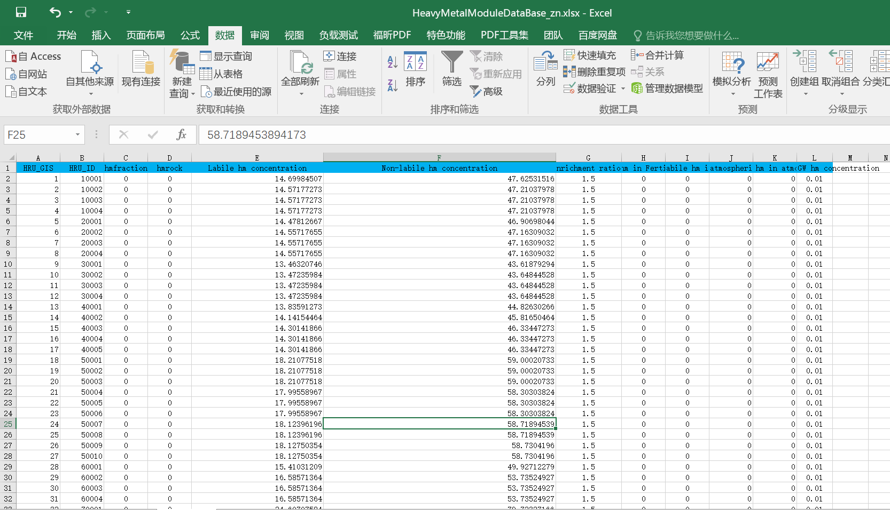

Fig. - Excel database of SWAT-HM model

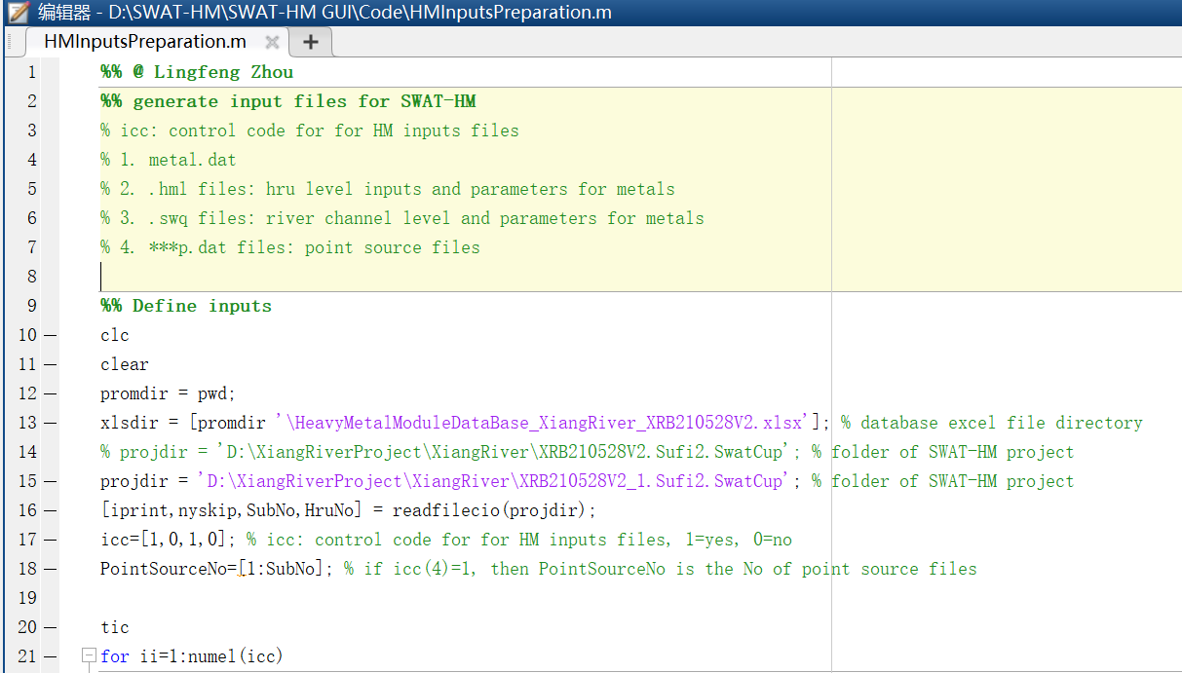

Fig. - Matlab script to create the input files of SWAT-HM model.

# Visualization

Python/Matlab code are posted on Github (https://github.com/LyntonZhou/SWAT-HM-pre-post-processing)

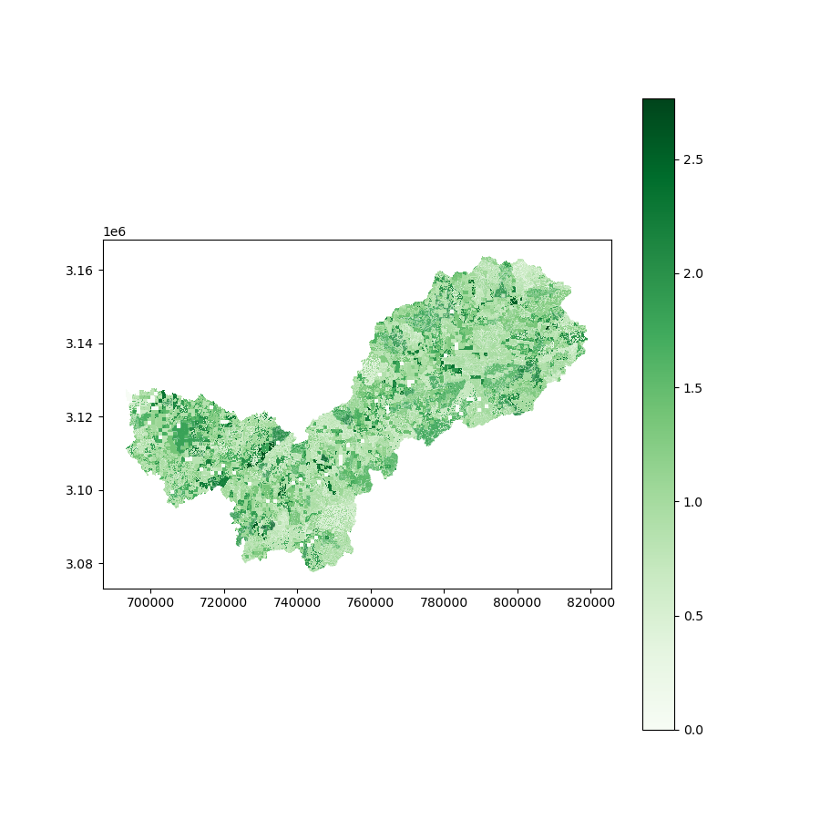

Fig. – Example of HRU output of SWAT-HM

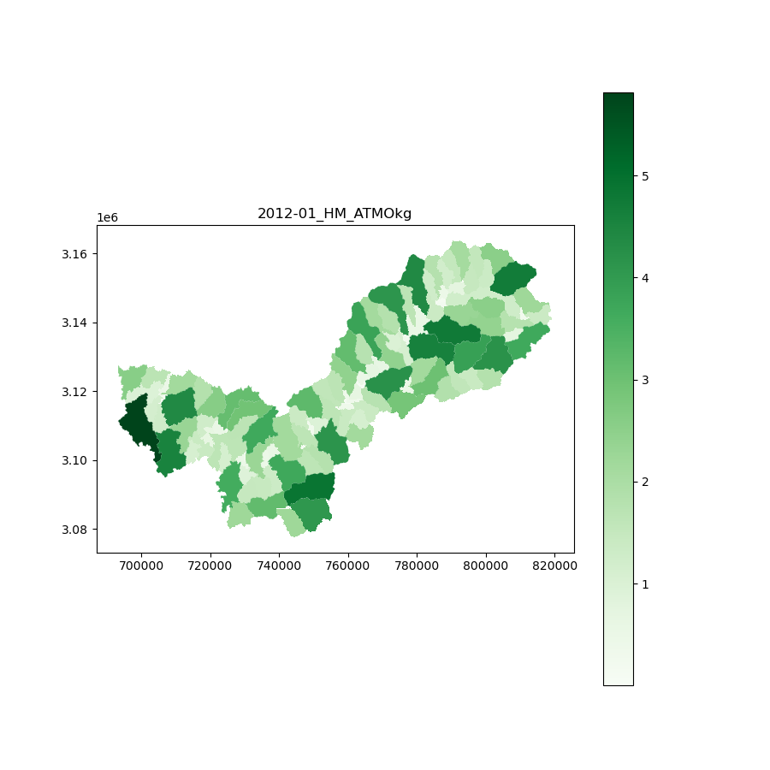

Fig. 9 – Example of subbasin output of SWAT-HM

# References

Bahr, J.M., Rubin, J., 1987. Direct comparison of kinetic and local equilibrium formulations for solute transport affected by surface reactions. Water Resources Research 23, 438-452.

Buekers, J., Degryse, F., Maes, A., Smolders, E., 2008. Modelling the effects of ageing on Cd, Zn, Ni and Cu solubility in soils using an assemblage model. European Journal of Soil Science 59, 1160-1170.

Chapra, S.C., 2008. Surface water-quality modeling. Waveland press.

Crout, N.M.J., Tye, A.M., Zhang, H., McGrath, S.P., Young, S.D., 2006. Kinetics of metal fixation in soils: Measurement and modeling by isotopic dilution. Environmental Toxicology and Chemistry 25, 659-663.

Debele, B., Srinivasan, R., Parlange, J.Y., 2008. Coupling upland watershed and downstream waterbody hydrodynamic and water quality models (SWAT and CE-QUAL-W2) for better water resources management in complex river basins. Environmental Modeling & Assessment 13, 135-153.

Degryse, F., Smolders, E., Parker, D.R., 2009. Partitioning of metals (Cd, Co, Cu, Ni, Pb, Zn) in soils: concepts, methodologies, prediction and applications – a review. European Journal of Soil Science 60, 590-612.

Ernstberger, H., Davison, W., Zhang, H., Tye, A., Young, S., 2002. Measurement and Dynamic Modeling of Trace Metal Mobilization in Soils Using DGT and DIFS. Environmental Science & Technology 36, 349-354.

Gualtieri, C., 1999. Sediments burial velocity estimation in Venice Lagoon, XXVIII IAHR Congress, pp. 22-27.

Lick, W., 2008. Sediment and contaminant transport in surface waters. CRC press.

Monteith, J.L., Moss, C.J., Cooke, G.W., Pirie, N.W., Bell, G.D.H., 1977. Climate and the efficiency of crop production in Britain. Philosophical Transactions of the Royal Society of London. B, Biological Sciences 281, 277-294.

Quinton, J.N., Catt, J.A., 2007. Enrichment of Heavy Metals in Sediment Resulting from Soil Erosion on Agricultural Fields. Environmental Science & Technology 41, 3495-3500.

Rubin, J., 1983. Transport of reacting solutes in porous media: Relation between mathematical nature of problem formulation and chemical nature of reactions. Water Resources Research 19, 1231-1252.

Williams, J.R., 1990. The Erosion-Productivity Impact Calculator (EPIC) Model: A Case History. Philosophical Transactions: Biological Sciences 329, 421-428.